Hour of Code

Computer Science Education Week (CSEdWeek) December 9-13, 2013
The Hour of Code is an opportunity for every student to try computer science for one hour. During Computer Science Education Week (Dec. 9-15), we're making history and recruiting 10 million to join in and do the Hour of Code in 167 countries.
Become a part of something HUGE! If you can create technology…you can change the world!

Start your Hour of Code
Activity
- Go to the URL hourofcode.com/co and start the tutorial. No need to sign in. Click GO.
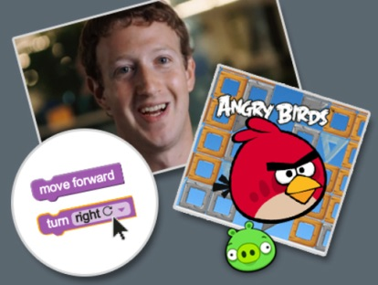
You can click the purple in the top right corner to begin immediately or you can watch the 2 minute video introduction before you begin.
GO

- You will have 20 puzzles to complete. Do what you can during class…some of you may finish all and some of you may not. That’s okay! This is not homework but you may want to revisit it again after class…because you can!
When you come across difficulties
- “Ask 3 then the teacher.” Ask 3 classmates, and if you don’t have the answer, then ask the teacher.
- Encourage each other! It’s okay if you are thinking “I don’t know but try to figure it out together.” We all know that “Technology doesn’t always work out the way we want. Together, we’re a community of learners.” And: “Learning to program is like learning a new language; you won’t be fluent right away.“
What to do if you finish early?
- You can try other tutorials at code.org/learn. Click on the purple bar and arrow to the right of Tutorials for beginners for the following choices once you’ve finished with Angry Birds.
  - Create a Holiday Card
  - Build your own game
  - Light Bot
- Or, if you finish early you can help classmates who are having trouble with the activity.
The Hour of Code is just the first step on a journey to learn more about how technology works and how to create software applications.

